Kingdom of Saudi Arabia
Ministry of Education

Course name : Database Concepts & Design
Project Title : Gym Membership System

Table of contents

- Introduction & Why using Database ……………………….. {3}
- System Analysis ……………………………………………… {4}
  - Requirement Specification {4 & 5}
  - List of Users {6}
  - List of Main Reports {6}
  - Key Relationships {7}
- ERD ……………………………………………………………{7}
- Logical Design…………………………………………………{8}
- Physical Design …………………………………………..{9 , 10}
- Queries………………………………………………… {11 , 12}
- Application Development………………………….{13,14 & 15}

- Introduction (Case Description)

Gyms and fitness centers use paper sign-up sheets or basic software to manage memberships, class bookings, and equipment maintenance. Members get upset when classes are overbooked or equipment breaks down without warning. Staff manually check membership cards, leading to security issues (unauthorized access), and managers can’t track peak hours or popular classes.

- Why using Database :
A database could allow members to book classes online, track attendance via QR codes, and send maintenance alerts for broken equipment. It could also block expired members from entering automatically and show managers which classes need more equipment or instructors. Members could even track their workout history.

- System Analysis :
  - Requirement Specification :

- Member Management :
- The system must store each member’s details:
- MemberID (unique identifier), full name, contact information (email, phone), join date, and assigned membership plan.
- Emergency contact details (name, relationship, phone).
- Members can update their profiles (change phone number) or cancel their membership.
- Class and Trainer Management :
- The gym offers fitness classes (Yoga, HIIT) with the following attributes:
- ClassID (unique), name, schedule (date/time), location, capacity, and assigned trainer.
- Each trainer has a TrainerID, name, specialization (Pilates, Strength Training), and contact information.
- A trainer can teach multiple classes, but each class is taught by one trainer.

- Equipment Tracking :
-All gym equipment (treadmills, dumbbells) must be cataloged with
- EquipmentID (unique), name, purchase date, status (Active/Under Maintenance), and last maintenance date.
- Maintenance must track repairs, including issue date and cost.

- Membership Plan Structure :
- The gym offers multiple membership plans ( Basic, Premium, Family). Each plan has a unique ID, name, price, duration (1 month, 6 months), and benefits (access to classes, personal training).
- A member can subscribe to only one plan at a time, but the gym can update or retire plans as needed.
- Maintenance Member :
- All gym equipment has to be maintained after a period of time.
- The maintenance Member has a unique MemberID, full name and a phone number

  - List of Users :
- Member
  - Books classes, updates profiles, subscribe .
- Trainer
  - Manages class schedules.
- Admin
  - Manages memberships, equipment, and reports.

  - List of Main Functions :
- Store and maintain member profiles, including personal details, membership plans, and emergency contacts.
- Organize classes with assigned trainers, schedules, and capacities to ensure efficient resource allocation.
- Manage membership plans (add, update, retire) and enforce plan-specific benefits.

  - List of Main Reports :
- Membership Statistics: Active vs. expired members, revenue per plan.
- Class Attendance Trends: Participation rates, peak hours, trainer workload.
- Plan Utilization Report: Popularity of plans and member retention rates.

  - Key Relationships :
- A Member subscribes to one Membership Plan (1:1).
- A Member attends many Classes, and a Class has many Members (M:N).
- A Trainer teaches many Classes (1:N).
- Maintenance members can maintain many equipment items (M:N).

- ERD :
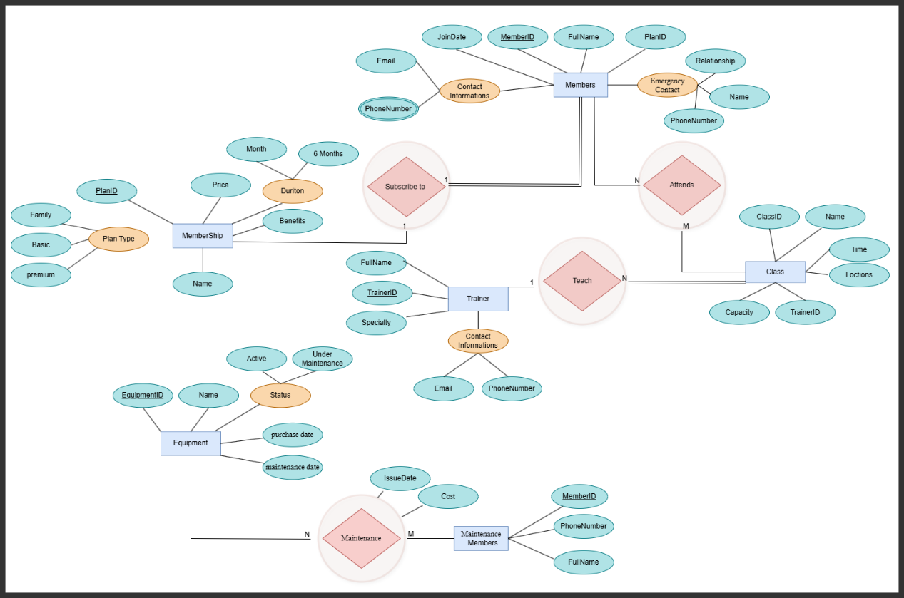

- Logical Design :
Member
Member ID (PK) | Name | Email | Phone | Join_ DATE | Plan ID (FK) | Emr contact name | Emr contact relationship | Emr contact phone

Membership plan
Plan ID (PK) | Plan Name | Price | Duration | Benefits

Trainer
Trainer ID (PK) | Name | Specialization | Contact

Class
Class ID (PK) | Class Name | Schedule | Location | Capacity | Trainer ID (FK)

Equipment
Equipment ID (PK) | Name | Purchase Date | Status | Last Maintenance Date

Maintenance
Maintenance ID (PK) | Equipment ID  (FK) | Issue Date | Cost

Maintenance Member
Maintenance Member ID (PK) | Name | Phone

Attendance
Member ID (PK) | Class ID (PK) | Attendance Date

Phone member
Member ID (PK) | phonenumber

- Physical Design :
CREATE TABLE Member | CREATE TABLE Member (  MemberID VARCHAR(10) PRIMARY KEY,  Name VARCHAR(50) NOT NULL,  Email VARCHAR(50) UNIQUE,  Phone VARCHAR(15),  JoinDate DATE,  PlanID VARCHAR(10),  EmergencyContactName VARCHAR(50) NOT NULL,  EmergencyContactRelationship VARCHAR(20),  EmergencyContactPhone VARCHAR(15) NOT NULL,  FOREIGN KEY (PlanID) REFERENCES MembershipPlan(PlanID)  );
CREATE TABLE MembershipPlan | CREATE TABLE MembershipPlan (  PlanID VARCHAR(10) PRIMARY KEY,  PlanName VARCHAR(20) UNIQUE,  Price DECIMAL(10,2),  Duration VARCHAR(15),  Benefits VARCHAR(200)  );
CREATE TABLE Trainer | CREATE TABLE Trainer (  TrainerID VARCHAR(10) PRIMARY KEY,  Name VARCHAR(50) NOT NULL,  Specialization VARCHAR(50),  Contact VARCHAR(15)  );
CREATE TABLE Class | CREATE TABLE Class (  ClassID VARCHAR(10) PRIMARY KEY,  ClassName VARCHAR(30) NOT NULL,  Schedule DATETIME,  Location VARCHAR(50),  Capacity INT,  TrainerID VARCHAR(10),  FOREIGN KEY (TrainerID) REFERENCES Trainer(TrainerID)  );
CREATE TABLE Equipment | CREATE TABLE Equipment (  EquipmentID VARCHAR(10) PRIMARY KEY,  Name VARCHAR(50) NOT NULL,  PurchaseDate DATE,  Status VARCHAR(20) CHECK (Status IN ('Active', 'Under Maintenance')),  LastMaintenanceDate DATE  );
CREATE TABLE Maintenance | CREATE TABLE Maintenance (  MaintenanceID VARCHAR(10) PRIMARY KEY,  EquipmentID VARCHAR(10) NOT NULL,  IssueDate DATE NOT NULL,  Cost DECIMAL(10,2),  Description VARCHAR(200),  FOREIGN KEY (EquipmentID) REFERENCES Equipment(EquipmentID)  );
CREATE TABLE MaintenanceMember | CREATE TABLE MaintenanceMember (  MaintenanceMemberID VARCHAR(10) PRIMARY KEY,  Name VARCHAR(50) NOT NULL,  Phone VARCHAR(15) NOT NULL  );
CREATE TABLE MaintenanceAssignment | CREATE TABLE MaintenanceAssignment (  MaintenanceMemberID VARCHAR(10),  EquipmentID VARCHAR(10),  AssignmentDate DATE NOT NULL,  PRIMARY KEY (MaintenanceMemberID, EquipmentID),  FOREIGN KEY (MaintenanceMemberID) REFERENCES MaintenanceMember(MaintenanceMemberID),  FOREIGN KEY (EquipmentID) REFERENCES Equipment(EquipmentID)  );
CREATE TABLE Attendance | CREATE TABLE Attendance (  MemberID VARCHAR(10),  ClassID VARCHAR(10),  AttendanceDate DATE NOT NULL,  PRIMARY KEY (MemberID, ClassID),  FOREIGN KEY (MemberID) REFERENCES Member(MemberID),  FOREIGN KEY (ClassID) REFERENCES Class(ClassID)  );

- Queries :
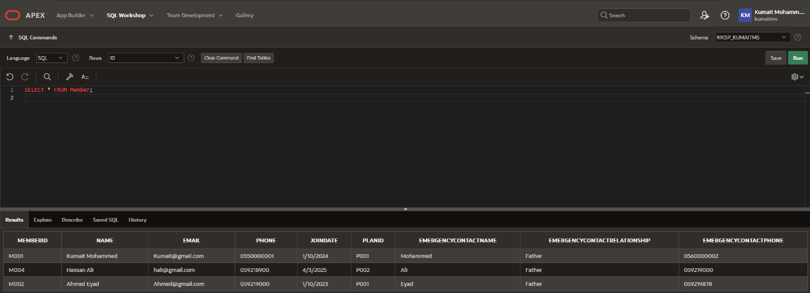
- List of all members :
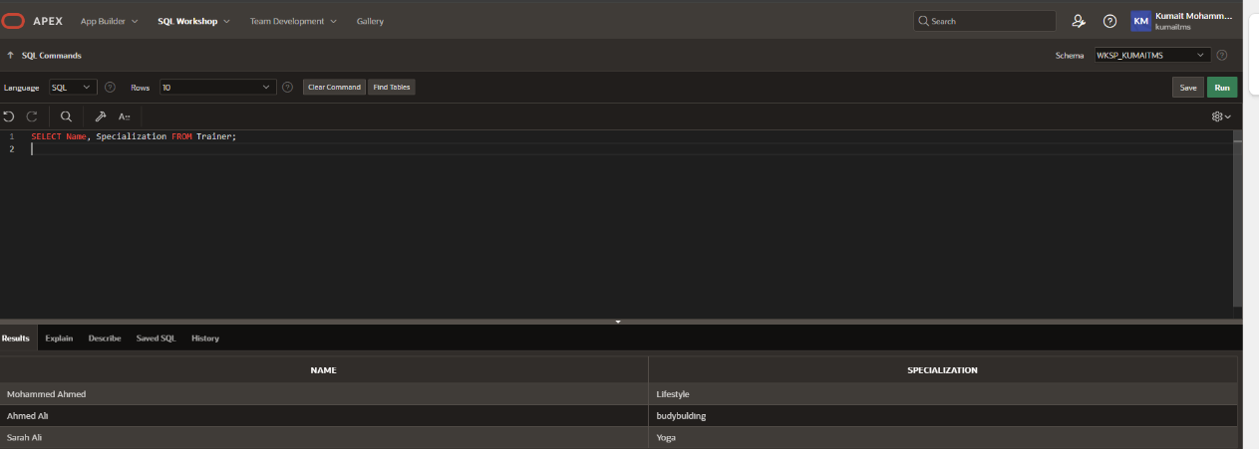
- List of all trainers and their specializations :

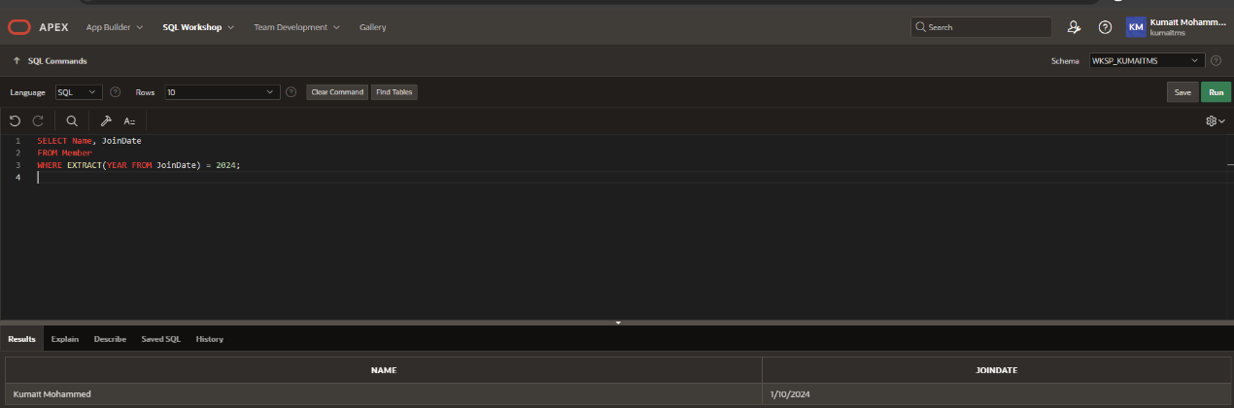
- Find members who joined in 2024 :

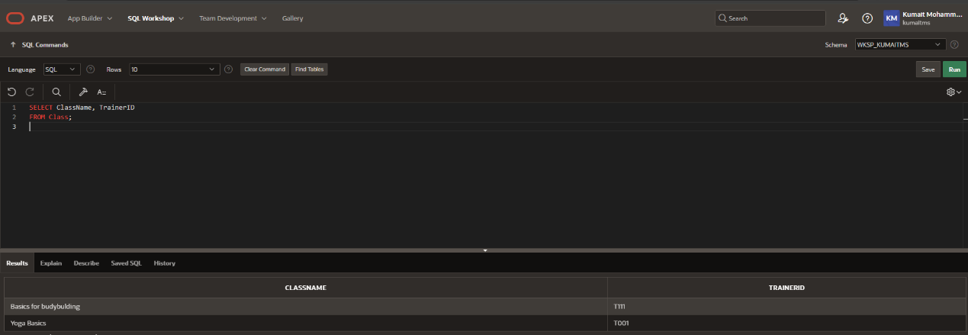
- List of classes and their assigned trainer :

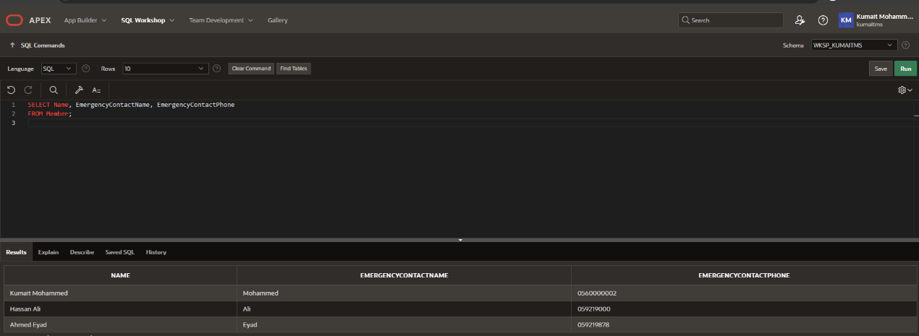
- Show all members and their emergency contact details:
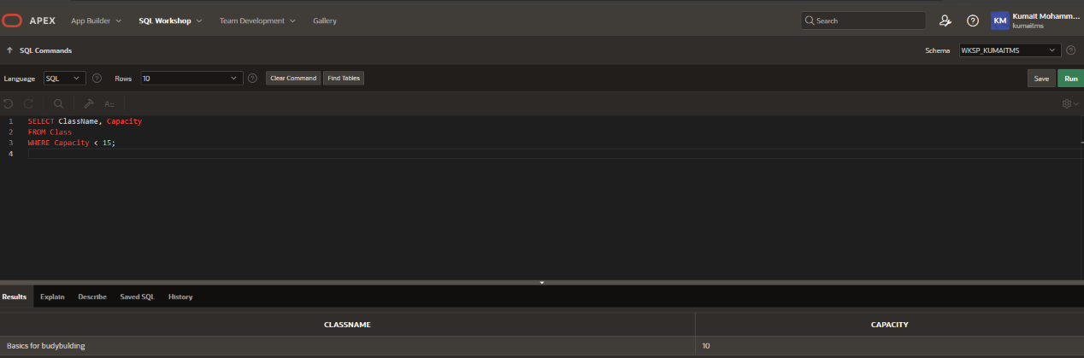
- List all classes with capacity less than 15 :

- Application Development :

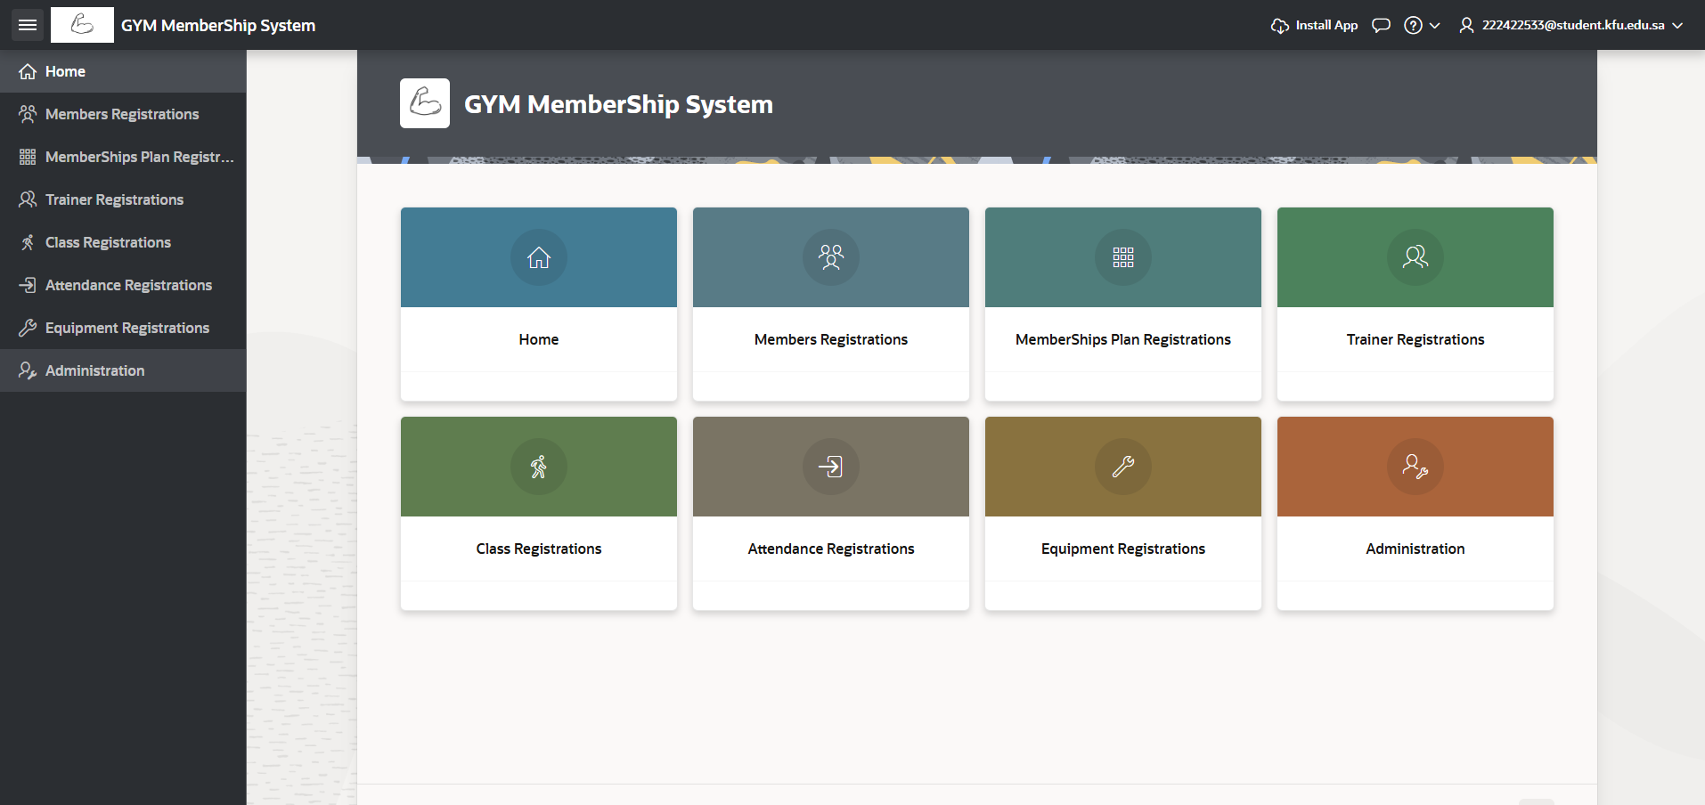
- App Interface & Quick Access to all components :

- Administration :
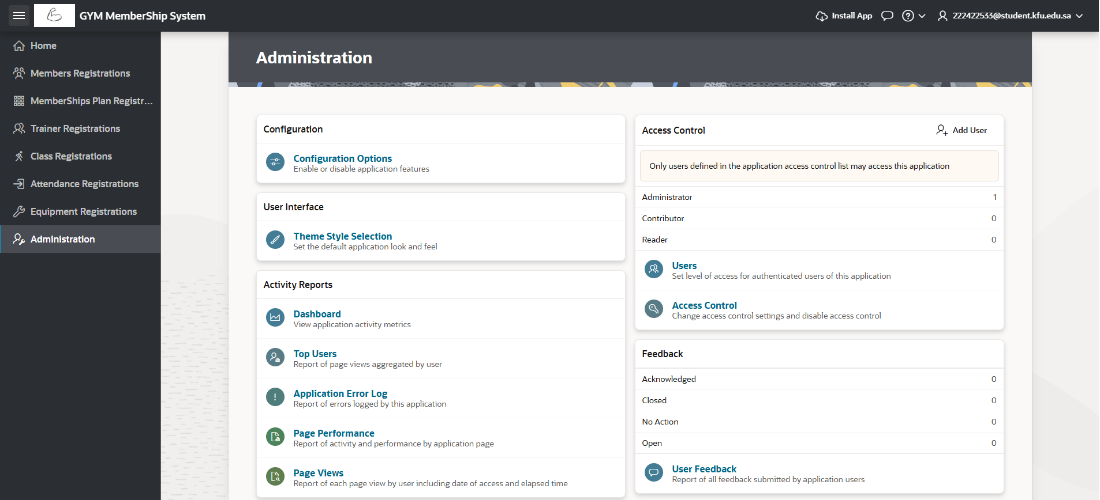

- Member registration Form & Report :
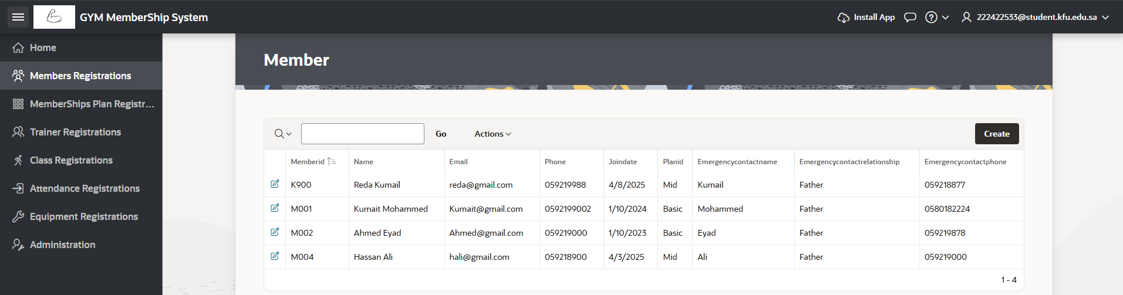
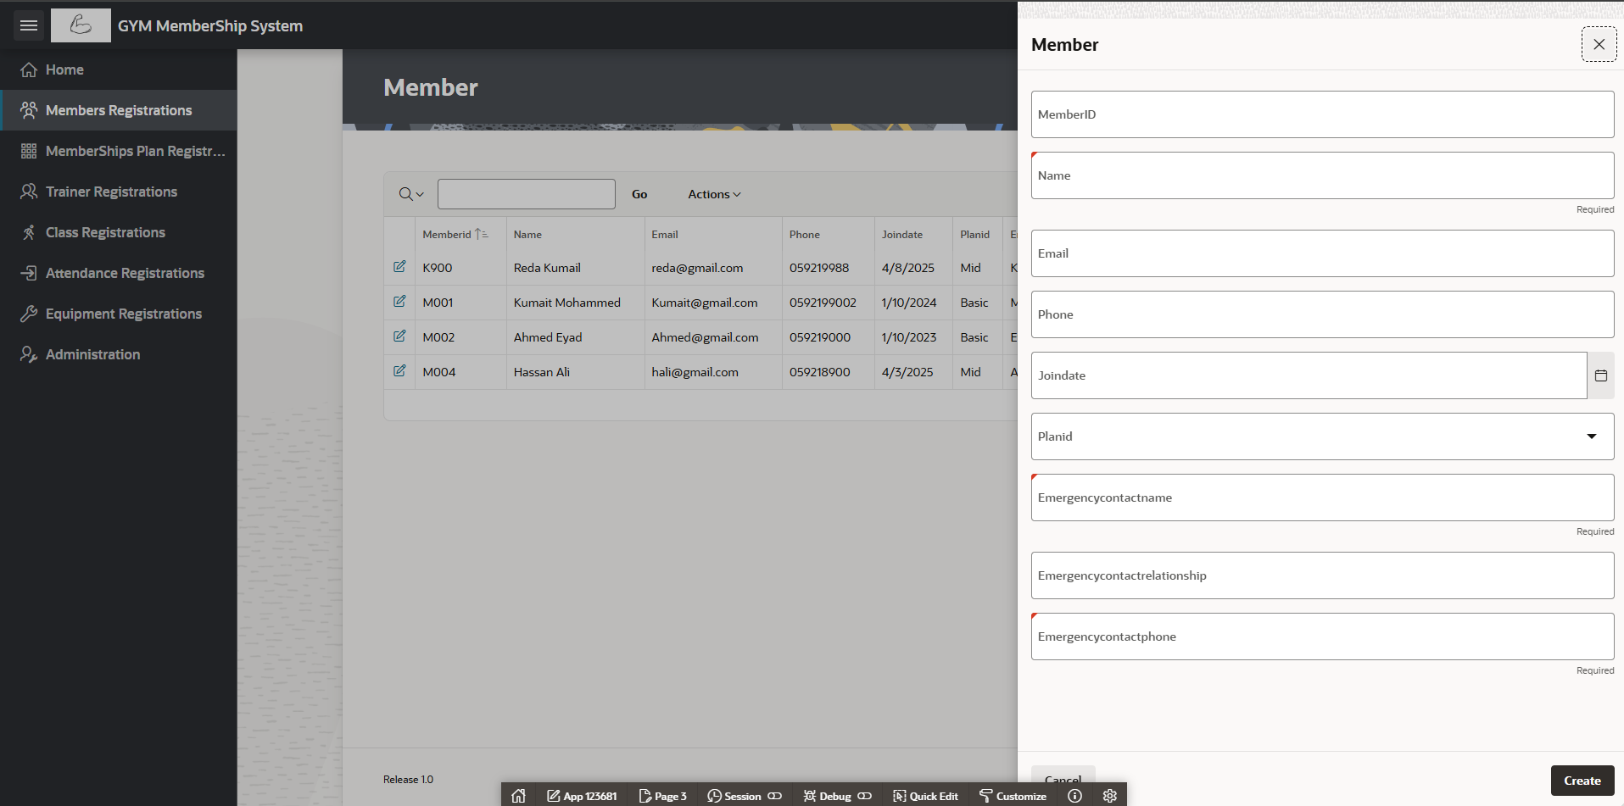

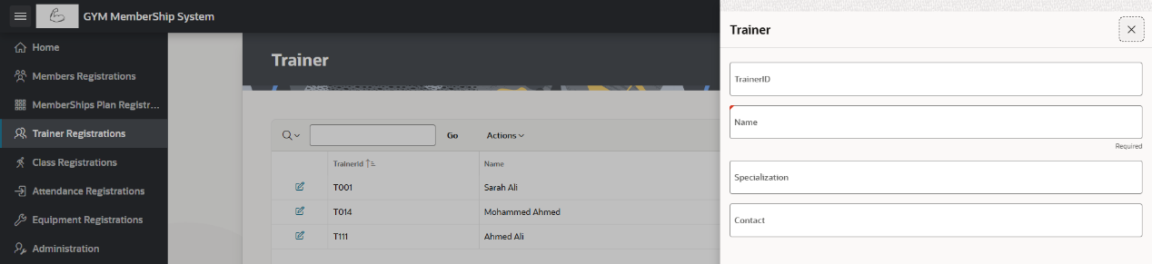
- Other Utilities :
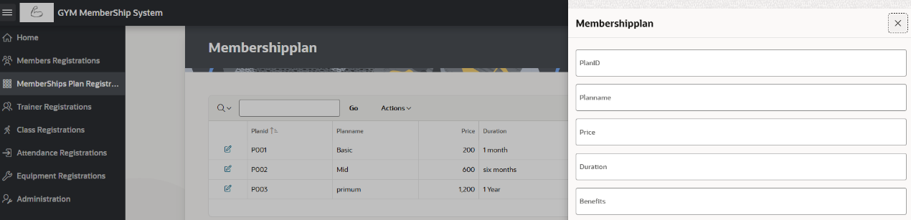
- To access Application above :
- https://apex.oracle.com/pls/apex/r/kumaitms/gym-membership-system/home?session=113420122062092
- Username : tester
- Password : tester2233

